# 

# Introduction to pastels

Pastels are a vibrant, versatile medium that artists have been using for centuries. They create stunning artworks with soft, velvety textures and rich, vivid colours, and come in a variety of forms, each with unique characteristics and applications, making them a popular choice for both beginners and experienced artists. Unlike paints or pencils, pastels are made of pure pigment that is bound together, allowing artists to work directly with colour in its most intense and raw form.

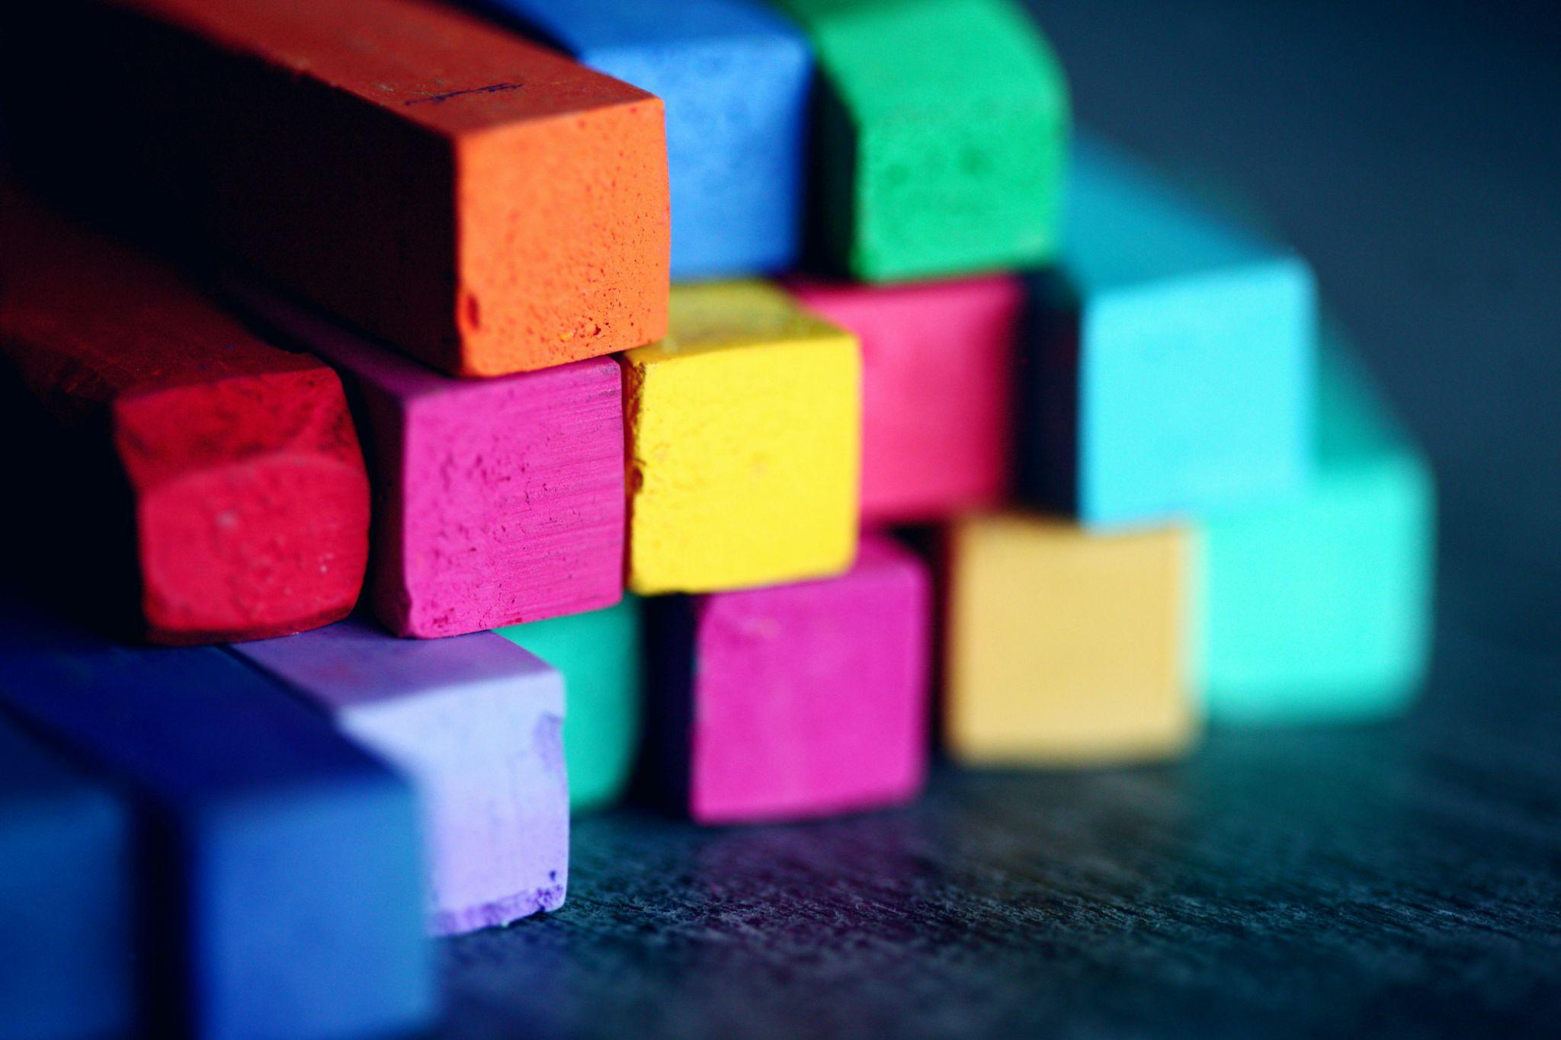

Fig. 1. Pexels (n.d.) Soft pastels

**Tools you need when working with pastels**

* Appropriate paper
* Pencil and eraser
* Hobby blade
* Wet wipes and plastic gloves if required

### Types of Pastels

### Soft pastel

These are the most traditional and commonly used form of pastel. They have a very high concentration of pigment with the least amount of binder. As a result they have a powdery texture and they crumble very easily.

### Hard pastel

They are made of the same ingredients as soft pastel but they contain more binder and a lower amount of pigment. As a result they don't have that powdery texture, but the colour is not as intense.

### Pastel pencil

They are most suited to controlled and detailed drawing and rendering. They are very similar to a conventional pencil, but within the wood is a very thin sliver of pastel. They can be used alone or can be combined with other pastels.

### Oil pastel

They are sticks of pigment bound with wax and oil. Unlike soft pastel they will not crumble or smear or release a fine dust. In addition, oil pastels contain a high concentration of pigment. They don't need a fixative but they harden instead of drying out completely.

**Tips**

* After selecting what type or combination of pastel you would prefer, begin with only a small set. A set of 12 is sufficient for a beginner
* Pastel paper is available in a variety of different textures and weights, but it is usually rougher than the paper used for acrylic or watercolour paint. Using a paper with texture will help grab the pigment and hold the colour better
* Experiment with the quality of each material as every material will have different properties that you should explore, prior to starting your first drawing.
* First, plan your drawing by lightly sketching it on your paper with a graphite pencil. Then lay down the main area of colour, and start with a light touch before gradually building up a darker colour.
* Blend your colour, and where needed, start layering different pastel colours over each other. This should help you achieve your desired effect.
* Mixing, or layering colours can add detailed texture to the drawing. Finish blending colours together, and remember to seal the drawing with fixative, in order to keep it protected and smudge free.

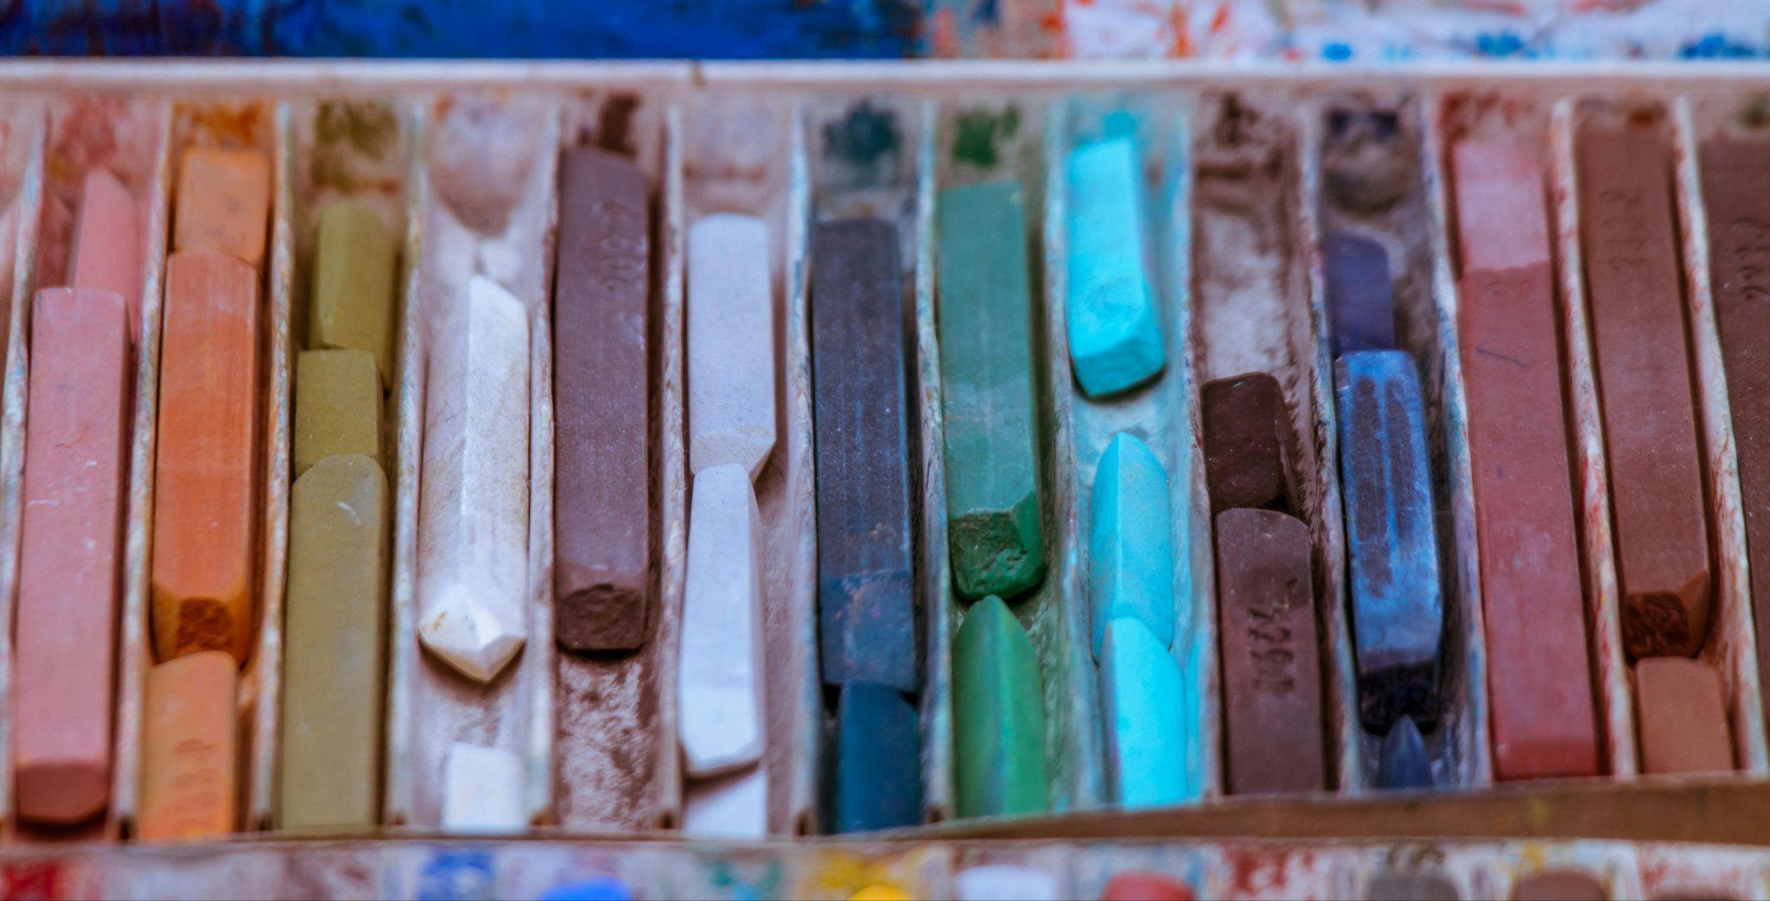

Fig. 2. Pexels (n.d.) Soft pastels

A Staedtler karat soft pastel chalk box set of 12 assorted colours was used for each example shown in this document. Please note: There is no obligation on you to buy this specific set – it is just an example of one of many options.

## Fixing and Preservation

Due to the fragile nature of pastels, sealing your final drawing after completion is an essential step. Pastels, especially soft pastels, have a loose, powdery texture that can easily smudge or be displaced from the surface of the paper. To ensure that your pastel artwork remains vibrant and intact, several steps can be taken for fixing and preservation.

* **Fixative spray:** Pastel artworks are fragile and can smudge easily. To preserve them, artists often use a fixative spray to lock the pastel particles in place. Should you have trouble accessing an arts and crafts specialist store, a good alternative to fixative spray is a standard hairspray.
* **Storage and framing:** Pastel drawings should be carefully stored, ideally under glass or in protective sleeves, as the loose pigment can be easily disturbed.

## Gradient (with one colour)

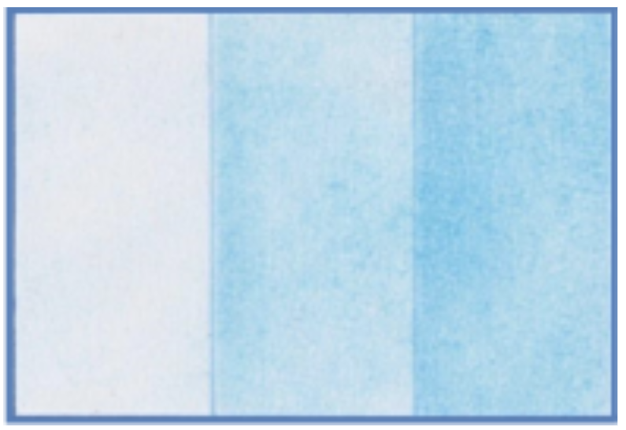

Fig. 3. Example of gradient with one colour (Blue)

The varying intensity of colour is created by applying a different amount of chalk pastel. In the example above the one colour is shown with a light to medium to heavy amount of chalk pastel applied to the paper.

## Blending

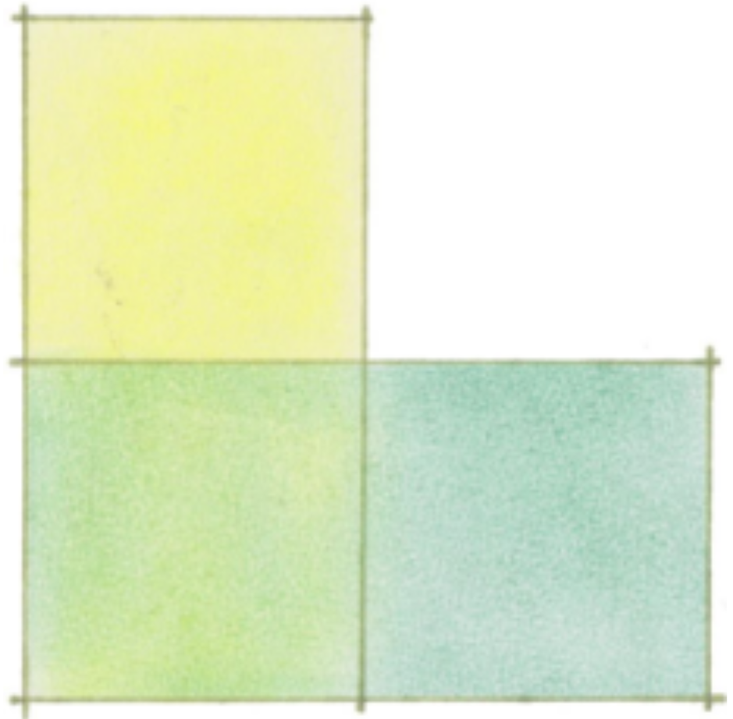

Fig. 4. Example of blending Yellow and Green

The top square in each example is rendered using the lighter colour and the square on the bottom right the darker colour. Then the square in between is a combination of both resulting in a new colour being created.

## Linear gradient

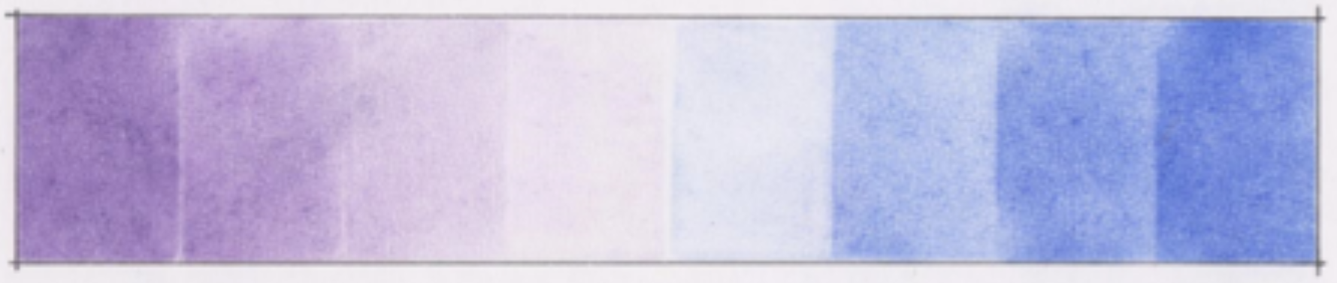

Fig. 5. Example of linear gradient from purple (left) to blue (right)

The colour gradient or colour progression shows a span of colour from purple to blue along a linear scale. The colour is shown by a graduated progression of a smooth colour transition from one to the next.

## Shape and shadow

### How to create a shaded pyramid

#### **Step 1**

* Draw a pyramid shape, preferably using a ruler to ensure the shape is correctly drawn. Note: use a purple colouring pencil for the outline of the pyramid.
* Then determine the direction of the sun and draw the outline of the shadow.

Note: use a black colouring pencil for the shadow. The direction of the sun is indicated by the orange arrow.

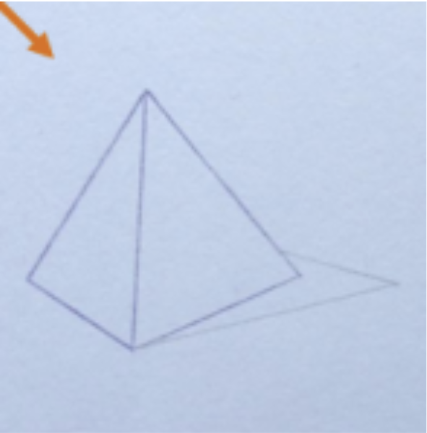

Fig. 6. Step 1

#### **Step 2**

Now you are ready to start introducing a little colour onto the pyramid shape.

* Firstly, using the soft purple pastel apply a light layer of colour to each side of the pyramid.
* In order to get a clean line along each side, use a sheet of paper as a guide and cover the edge of the shape. This will ensure the soft pastel will stay within the shape.
* For the side of the pyramid that is farthest from the light source, you want to get a slightly deeper colour. In order to achieve this, you will need to apply a second layer of the soft purple pastel.

Shadow Area: Using the soft black pastel apply a single layer to the shadow area cast by the pyramid shape.

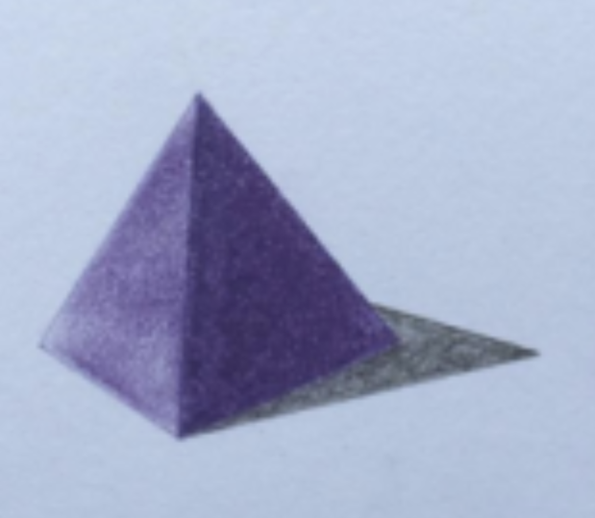

Fig. 6. Step 2

#### **Step 3**

* Using your finger, very carefully start blending the colour together for each side of the pyramid shape and the shadow area. If further colour is required simply add another layer of the soft purple pastel, remembering the direction of the sun.

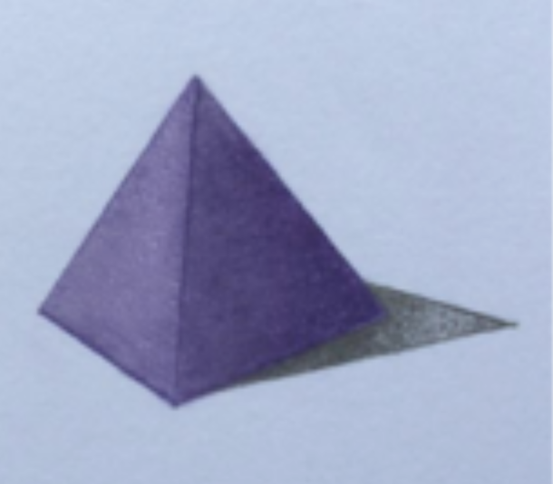

Fig. 7. Step 3

To finish, redefine the outline of both the pyramid shape with a purple colouring pencil, and the shadow area with a black colouring pencil.

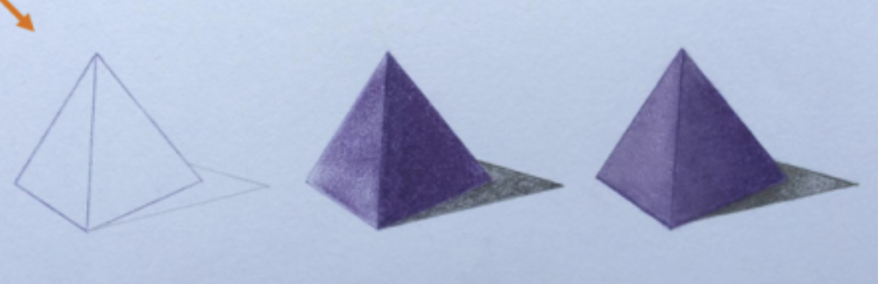

Fig. 8. Overview of how to create a pyramid

## Challenges of Using Pastels

* **Fragility and smudging:** The loose pigment in soft and hard pastels can easily smudge or crumble, making the work delicate. Careful handling and the use of fixatives are necessary.
* **Dust:** Working with soft pastels can generate dust, which may be a concern for some artists, particularly those with allergies. It's important to work in a well-ventilated area.
* **Difficulty in detail:** While pastel pencils and hard pastels allow for more detailed work, soft pastels can be difficult to control for fine lines and small details.

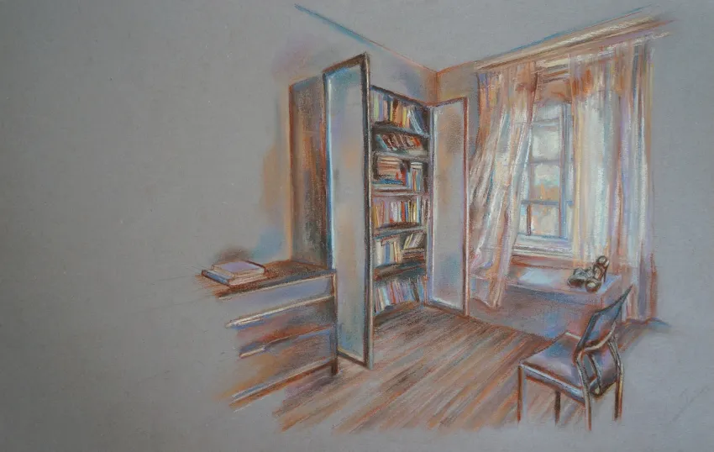

Fig. 9. Pastel architectural interior: Bedroom

Pastels are a dynamic and expressive medium that offers a unique way to create both bold and delicate artwork. With a range of types and techniques, they provide artists with the freedom to experiment with colour, texture, and form. Whether you're new to pastels or looking to refine your skills, this medium offers endless possibilities for creativity and artistic exploration.